VELS INSTITUTE OF SCIENCE, TECHNOLOGY AND ADVANCED STUDIES
SCHOOL OF ENGINEERING
Department of Computer Science and Engineering
July 2026 to Nov 2026
SUBJECT TITLE: Maximum Marks: 50
SUBJECT CODE: YEAR/SEM: I/I
Registration No: |  |  |  | Invigilator Name & Signature:
CAT | I | Date: | Duration : 90 min
Q.No | PART-A (Answer ALL the questions) |  |  | Marks | CO | Knowledge Level | Marks awarded | Total Marks of CO’s
1 | What is a variable in C? Give an example. |  |  | 2 | 1
2 | Name any four basic data types supported in C |  |  | 2 | 1
3 | Explain the purpose of the printf() and scanf() function in C. |  |  | 2 | 1
4 | What is the role of a compiler in the execution of a C program? |  |  | 2 | 1
5 | Find the output: int a=7,b=2; printf("%d",a%b); |  |  | 2 | 1
6 | Define the if statement in C. |  |  | 2 | 2
7 | Give the general syntax of the if-else-if ladder. |  |  | 2 | 2
8 | Differentiate between entry-controlled and exit-controlled loops. |  |  | 2 | 2
9 | What is the ternary operator? Give its syntax. |  |  | 2 | 2
10 | Find the output: int x=10; if(x>5) printf("A"); else printf("B"); |  |  | 2 | 2
PART – B (Answer all the Questions)
11a | Explain in detail the structure of a C program with a neat diagram and suitable example. |  |  | 15 | 1
(or)
11 b | Explain arithmetic, relational and logical operators in C with example programs illustrating each. |  |  | 15 | 1
12 a | Discuss the various looping constructs available in C and analyze their suitability for different problems. |  |  | 15 | 2
(or)
12 b | Explain the different forms of the if statement in C with suitable examples. |  |  | 15 | 2

CO1(Marks Obtained): | CO2(Marks Obtained): | Total Marks Obtained
Evaluator( Name& Designation): Evaluator Signature: Student Signature:

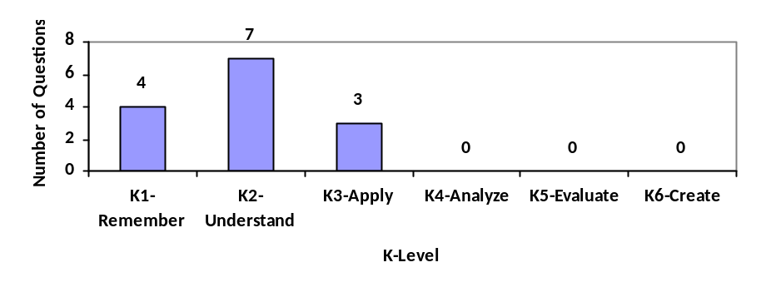

Distribution of Questions based on Bloom’s Taxonomy-Knowledge Level

